# Important Supplementary Note (MUST READ)

This supplementary note describes changes made to ANL252 Python for Data Analytics:

1. **Study Unit 1**: Chapter 1 is to be replaced by the Appendix 1. The reason for this change is to facilitate students’ learning of the programming language without having to switch to different programming enviroments.
2. **Study Unit 5**: Only Chapter 1 will be covered. The class activities will include an exercise on building a regression model. Note Chapters 2 (on Clustering) and 3 (on Decision Tree) are optional. Your instructor may run through them if time permits.
3. **Study Unit 6**: We will cover Chapter 1, and only cover up to the end of Section 2.1 of Chapter 2. The rest of the study unit will be optional.
4. **Additional class activities** related to data analysis will be added to help enhance your learning experience. These will be mentioned in the seminar slides.

It is hoped that these changes will help you learn better and pique your interest in learning more.

# Appendix 1

# The following replaces Study Unit 1, Chapter 1:

# Chapter 1: Python Programming Environment



**Lesson Recording**

[Introduction to Python Programming](https://d2jifwt31jjehd.cloudfront.net/ANL252/LessonRecording/ANL252_SU01CH01_H4_0_V1_0/presentation_html5.html)

## Installation of Python

Note that this study guide was originally developed based on Python Version 3.9.0 and Atom editor.

However, we have decided to switch to Jypyter Notebook/Lab to as the environment is more user friendly. In particular, you should install the Anaconda distribution at <https://www.anaconda.com/>. This installation comes with Jupyter Lab, Jupyter Notebook, Spyder, R Studio etc.). To install, use the default installation option and when done, choose the Jupyter notebook (anaconda3) from Window’s Start menu as shown in Figure 1.1. Because Anaconda come with most packages installed, you will **no longer need** to use the pip install commands that you see throughout this Study Guide to install different packages.

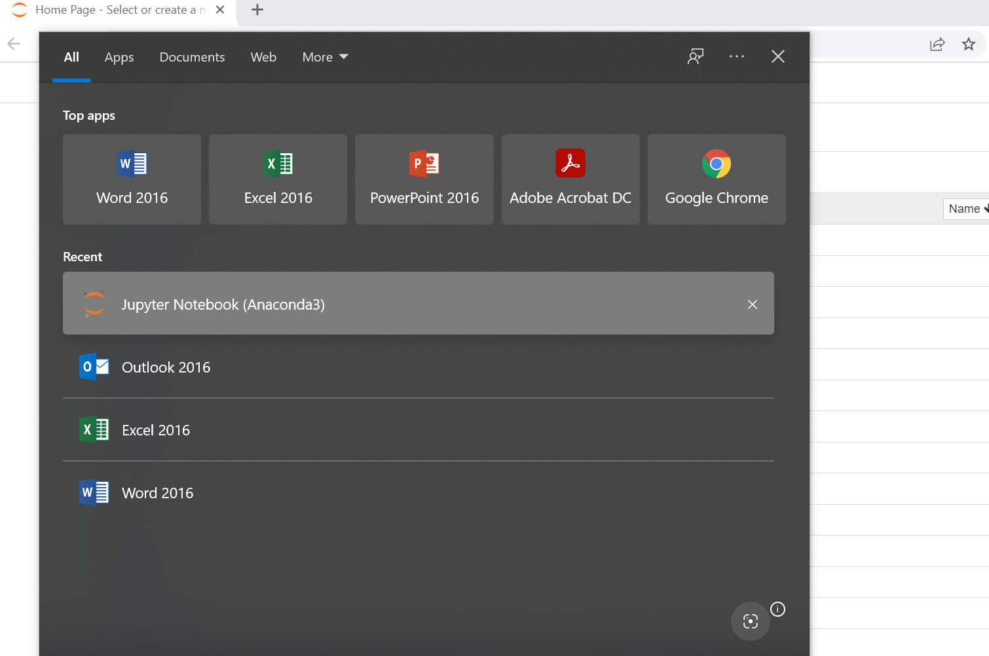

**Figure 1.1** Starting Jupyter notebook

In this Study Guide, we will standardise the operating system to Windows 10. If you encounter installation issues, you may also start by using the JupyterLab at:  <https://jupyter.org/try-jupyter/lab/>  Visit this page and the following screen will appear. You can start a new notebook by clicking on the Pyolite icon (more instructions will follow later).

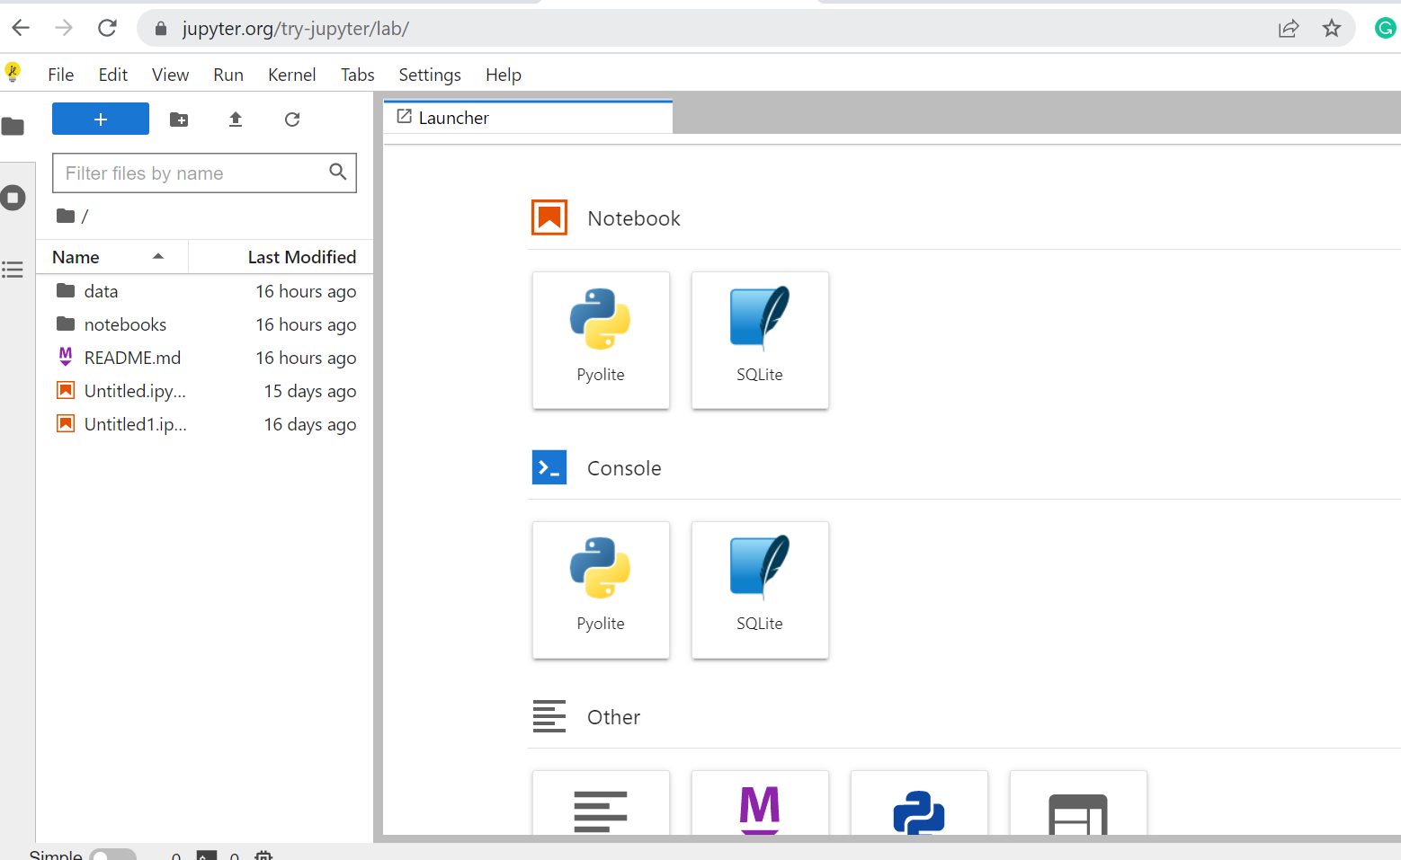

**Figure 1.2** JupyterLab interface



**Read**

This Study Guide has been developed based on Python 3 and was using Atom as the code editor. The look and feel of the user interface is different as compared to one who uses the Jupyter Notebook/Lab. If you would like to try Python 3 (which is **totally optional and not required for this course**), you should read the following two sections of the textbook on installing Python 3 on mac OS or Windows:

Exercise 0. The Setup (Windows); or

Exercise 0. The Setup (macOS)

If you want to try this optional task, you are also strong encouraged to do so on a **different** computer, to avoid any software conflicts with your existing Anaconda installation.

## Writing and Executing Python Programs

We can start writing our Python program on Jypyter Lab web application directly. Recall that JupyterLab can be launched by typing in the following URL (<https://jupyter.org/try-jupyter/lab/>) in the address bar of your internet browser (Google Chrome was used here). Then, click **Pyolite** icon under the Notebook section.

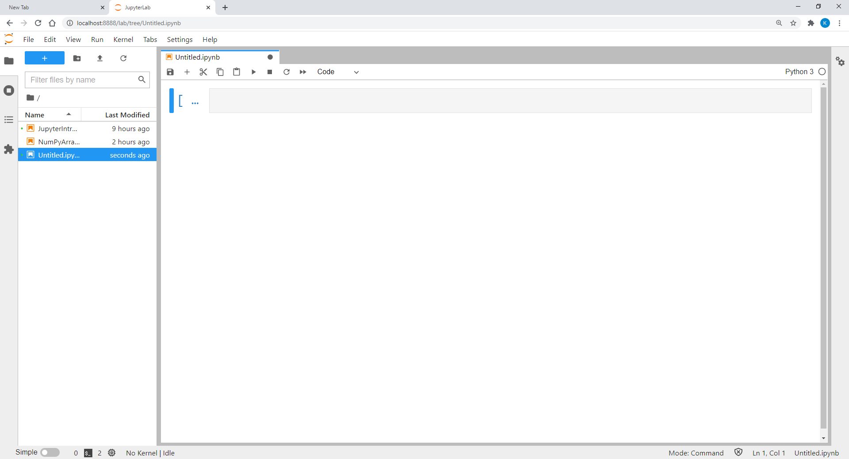

**Figure 1.4** JupyterLab Input cell for Python code entry

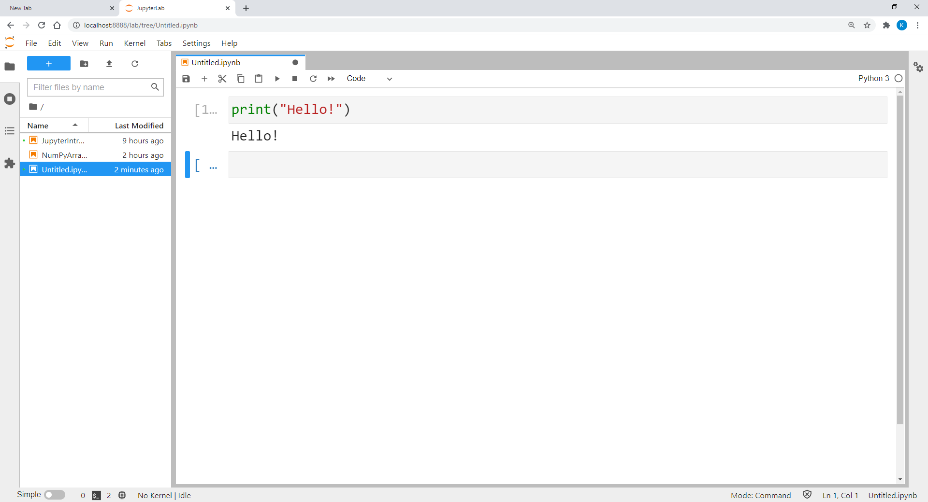

**Figure 1.5** JupyterLab shows the output after the code is run

Once we see Figure 1.4, we can type in our Python code in the cell and let the Python interpreter execute it by pressing the play button (c.f., Figure 1.5) once the syntax is completed. The output of the program will then be printed below the input cell.















































**References**

Atom.io. (n.d.). *A hackable text editor for the 21st Century*. GitHub. [https://atom.io](https://atom.io/)

Shaw, Z. A. (2017). *Learn python 3 the hard way*. Addison-Wesley Professional.